JECRC
JAIPUR
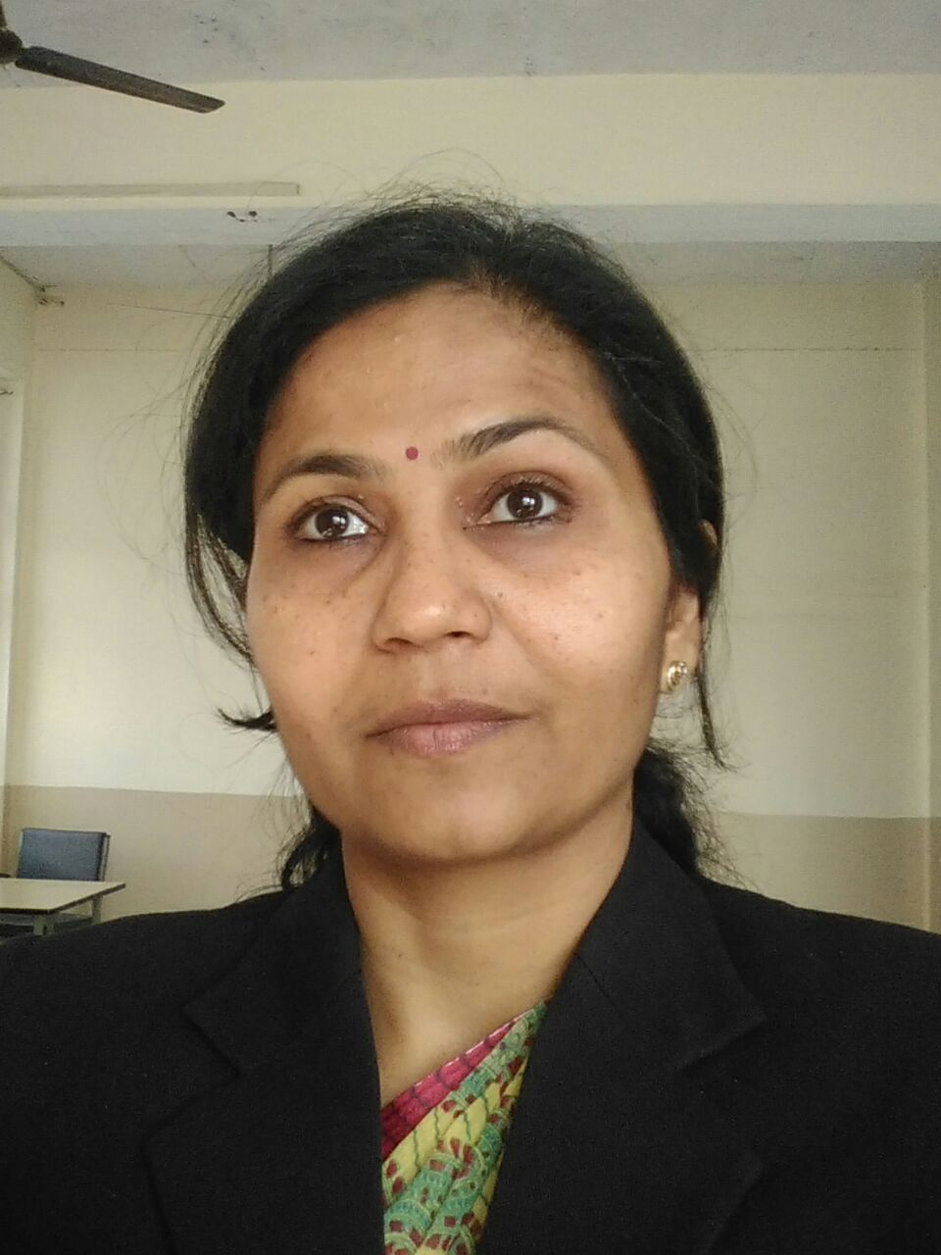

INDIVIDUAL FACULTY DATA SHEET
Name of the faculty member | : | KRITI MANISH SHARDA  **************
Present Designation | : | ASSITANT PROFESSOR  ****************
Email Id:kritisharda.ece@jecrc.ac.in
Contact Details:9785003123

I. Particulars of Educational Qualification: (only completed)

Category | Name of the Degree | Specialization | Year of Passing | Name of the College | Name of the University
UG | B.E | ELECTRONICS | 1994 | RKNEC | NAGPUR UNIVERSITY
PG | M TECH | VLSI DESIGN | 2010 | MNIT,JAIPUR | MNIT,JAIPUR
Ph.D. | - | - | - | - | -

II. Academic Experience : 13

III. Industrial Experience :4

IV. Title of Ph.D. Thesis :-

V. Awards/Achievements : -

VI. Research/Specialization : VLSI DESIGN

VII. Course Taught : BCA,BTECH

VIII. Refereed International Journal Publication :

IX. International Conference Proceeding :

X. Books Written :

XI. M.Tech Thesis Guide : MR, SANJEEV AGARWAL

XII. PHD Thesis Guide :

XIII. Professional Body Membership :

